**Technical Documentation – Deploy_EDT**

1. Workflow – Deploys EDT Liferay and Business Services Artifacts to an Environment from EDT Build directories.

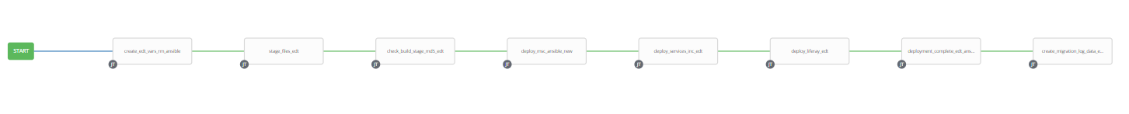

1. Survey – User Supplied Variables

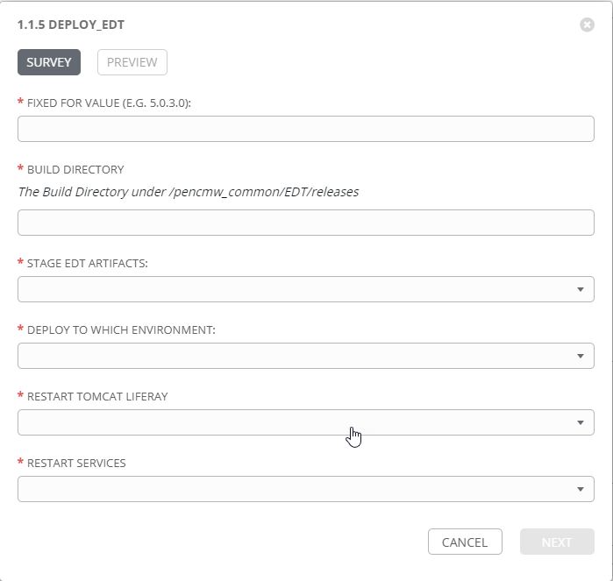

|  |  |  |  |
| --- | --- | --- | --- |
| **Survey Extra Variables** | **Prompt** | **Type** | **Description and Usage** |
| FFV | Fixed For Value | Text | The fixed for value for the deployment – must be for the format ###.###.###.### (i.e. 58.0.12.0). Numbers only with a maximum of 3 digits and there must be 4 sets separated with a ‘.’. Used to create staging and deployments directories. Used by all job templates in the workflow |
| ReleaseDir | Build Directory | Text | The /pencmw_common/EDT/releases/ subdirectory that contains the EDT Liferay and Business Services artifacts |
| STAGE | Stage MOS Artifacts | Multiple Choice Single Pick | true or false – Copies the Liferay and Business Artifacts from the EDT Build Releases Directory to the Staging folder. |
| ENV | Deploy to Which Environment | Multiple Choice Single Pick | The Environment to Deploy to: DEV, TEST, MAINT or PROD. Only a single environment can be deployed to per workflow execution |
| RESTART_LIFERAY | Restart Tomcat Liferay | Multiple Choice Single Pick | true or false – if true restart the Liferay Tomcat |
| RESTART_SERVICES | Restart Services | Multiple Choice Single Pick | true or false – if true restarts ALL of the Business services on the xbusser1bcp and xbusserv2bcp |

EXTRA VARIABLES – at Workflow Level

|  |  |  |
| --- | --- | --- |
| **Extra Variables** | **Value** | **Description and Usage** |
| migration_log_url | http://dardanos1bcp.penc.local:7005/ords/devops/test2/log/record2/new/ | The URL for APEX/ORDS that houses the migration_log table. |

1. Jobs Used by the workflow - http://owl.penc.local:18080/svn/deploy_automation/trunk/Ansible_PlayBooks/MOS

| **Job Template** | **Ansible Playbook** | **Credential / host** | **Project** | **Description and Usage** |
| --- | --- | --- | --- | --- |
| create_edt_vars_rm_ansible | create_edt_vars_rm_ansible.yml | None – runs on localhost as awx linux user | EDT Deployments | DeploymentLogDir: /codemove_common/dp_automation/deployments/000.000/000.000.000.010/EDT  FQ_ReleaseDir: /pencmw_common/EDT/1.0/2021-10-12_100001  StageDir: /codemove_common/dp_automation/stage/000.000/000.000.000.010/EDT  date_time: '20211015_1125'  deploy_portlets: true  deploy_services: true  deploy_themes: true  liferay_deployment_host: 'dliferay71bcp,dliferay72bcp'  liferay_port: 4443  services_deployment_host: 'dbusserv1bcp,dbusserv2bcp'  stage_server: diagoras1bcp  tower_hostname: pdeploy1bcp.penc.local |
| stage_files_edt | stage_files_edt.yml | codemove on {{stage_server}} – typically diagoras1bcp | EDT Deployments | Copies EDT Artifacts from /pencmw_common/EDT/releases/{{ReleaseDir}} to the {{StageDir}}/{{ReleaseDir}}  The job fails if the /pencmw_common/EDT/releases/{{ReleaseDir}} build directory does not exist.  If the stage_server is set to ‘none’ as opposed to diagoras1bcp, the playbook does not actually do anything, all of the tasks are skipped.  Creates md5 checksum files for the EDT artifacts in both /pencmw_common/EDT/releases/{{ReleaseDir}} and {{StageDir}}/{{ReleaseDir}}. These files are then checked on the deployment hosts to ensure no errors were created during the staging process. This eliminates any issues with the NFS Cache problems  The last task of the job creates a Staging Report in the {{DeploymentLogDir}} in html format. |
| check_build_stage_md5_edt | check_build_stage_md5_edt.yml | pencmw on {{liferay_deployment_host}},{{services_deployment_host}} | EDT Deployments | On each host that is to be deployed to and if {{DeploymentLogDir}}/{{ReleaseDir}}/pencmw_common.md5 and/or {{DeploymentLogDir}}/{{ReleaseDir}}/codemove_common.md5 exist execute an md4sum |
| deploy_msc_ansible_new | deploy_msc_ansible_new.yml  calls:  deploy_tomcat_war.yml | Pencmw on node1 of the liferayhost {{deployment_host}} | MOS Deployments | On the {{deployment_host}} deploys msc artifacts in the {{StageDir}}/{{ReleaseDir}}/apps_msc.  It then restarts the MSC Tomcat application server. |
| deploy_services_inc_edt | deploy_services_inc_edt.yml  Calls  deploy_single_service_inc_edt.yml | pencmw on {{services_deployment_host}}  such as tbusserv1bcp, tbusserv2bcp | EDT Deployments | If {{services_deployment_host}} is defined as a valid services host  If {{RESTART_SERVICES}} and {{deploy_services}} are both set to true, stops all of the Business Services and deploys any business services to {{ENV}} that have been staged, then starts all of the Business Services.  If {{RESTART_SERVICES}} is false and {{deploy_services}} is true, stops each service present in the stage directory, deploys it and then starts it.  If both {{RESTART_SERVICES}} and {{deploy_services}} are false – does nothing  If {{services_deployment_host}} is set to None – does nothing  The playbook operates in serial mode so it deploys to a single server at a time (i.e. no outage in a load balanced environment) |
| deploy_liferay_edt | deploy_liferay_edt.yml | pencmw on {{liferay_deployment_host}}  such as tliferay71bcp, tliferay72bcp | EDT Deployments | If {{liferay_deployment_host}} is set to valid liferay host(s).  If {{deploy_portlets}} is true deploys any portlets in the build  If {{deploy_themes}} is set to true deploys any themes in the build.  If {{RESTART_LIFERAY}} is true and {{liferay_deployment_host}} is set to valid liferay hosts the tomcat application server is restarted.  The playbook operates in serial mode so it deploys to a single server at a time (i.e. no outage in a load balanced environment) |
| deployment_complete_edt_ansible | deployment_complete_edt_ansible.yml | pencmw on pdeploy1bcp set in playbook | EDT Deployments | Populates an html formatted deployment log {{DeploymentLogDir}}/{{ReleaseDir}}/{{ENV}}_MOS_{{date_time}}.html |
| create_migration_log_data_edt_new | create_migration_log_data_edt_new.yml | pencmw on pdepoy1bcp and awx_database | EDT Deployments | Populates migration_log table in APEX defined by the EXTRA VARIABLE {{migration_log_url}} |